**AECHE11 TASK 6 and 7**

**ANSWER KEY**

**ORGANIC CHEMISTRY and CHEMICAL REACTIONS**

Chapter 3.8, 4.1, 4.2 and 4.4

**Contains: Multiple Choice**

**Short answer**

**and Research Questions**

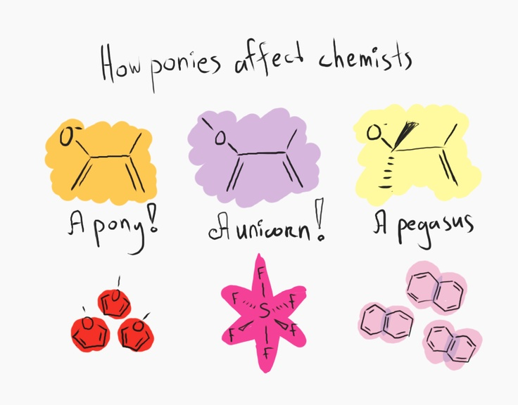

# PLEASE DO NOT TURN THE PAGE UNTIL INSTRUCTED TO DO SO

#### TASK 6 PART A: Multiple Choice [15 marks]

**Mark your answers on the sheet provided.**

1.The general formula for noncyclic alkenes is:

1. CnH2n+2
2. **CnH2n**
3. CnH2n-2
4. CnHn+2

2. The IUPAC name of the compound CH3CHCH2CH2CH3

|

CH3

1. 3-methylpentane
2. 4-methylpentane
3. **2-methylpentane**
4. methylpentane
5. Which one of the following compounds is saturated?
   1. CH2CH2
   2. CH3CHCH2
   3. C6H6
   4. **(CH3)3CH**

4. The addition of Br2 to cyclohexene gives:

1. 1,2 – bromocyclohexene
2. bromocyclohexane
3. 1 – bromocyclohexene
4. **1,2 – dibromocyclohexane**

5. Petrol consists of compounds with which number of carbon atoms in its molecules?

* 1. C1 to C5
  2. **C6 to C10**
  3. C11 to C12
  4. C13 to C25

6. The correct formula for copper (II) phosphate

     a)  Cu3(PO3)2  
     b)  Cu2PO3  
     c)  **Cu3(PO4)2**  
     d)  Cu2(PO4)3

7. Which of the following compounds does not exist in two or more structural forms?

1. C4H10
2. C2H4Cl2
3. **C2HCl3**
4. C2H2Cl2

8. The products of the balanced equation for the combustion of propane in plentiful air are:

1. 2CO2 + 4H2O
2. 3CO + 4H2O
3. **3CO2 + 4H2O**
4. 3CO2 + 8H2O

9. A compound mistakenly named 3,4 – dimethylbutane should be named correctly,

according to IUPAC rules as:

1. 2,3 – dimethylbutane
2. 2 – methylpentane
3. 1,2 – dimethylbutane
4. **3 – methylpentane**
5. Two organic compounds are structural isomers of each other if they

**a) have the same molecular formula but different structural formulae**.

b) have the same structure in the solid state but different melting temperatures.

c) differ from each other by a CH2 unit.

d) have the same physical properties but different molecular formulae.

11. Which of the following equations is NOT balanced?

a) 2H2S(g) + 3O2(g) 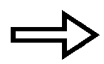 2H2O(g) + 2SO2(g)

b) 2C2H6(g) + 7O2(g)  4CO2(g) + 6H2O(g)

c) HCl(aq) + NaOH(aq)  H2O(l) + NaCl(aq)

d) **3NO(g) + 2O2(g)  3NO2(g)**

12. Two compounds which have the same molecular formulae, but different structural

formulae are:

* 1. 1-chloropropane and 3-chloropropane.
  2. butanal and butanone.
  3. propane and propene.
  4. **butane and 1-methylpropane.**

13. How many isomers are there for C3H6Cl2?

1. 3
2. **4**
3. 5
4. 6

14. Which of the following statements is **FALSE** for the chemical equation given

below in which nitrogen gas reacts with hydrogen gas to form ammonia gas assuming the reaction goes to completion?

N2 + 3H2 ➔ 2NH3

1. The reaction of one molecule of H2 will produce 2/3 molecule of NH3.
2. One molecule of N2 will produce two molecules of NH3.
3. **One molecule of nitrogen requires three atoms of hydrogen.**
4. To produce one molecule of NH3 you require 1/2 molecule of N2.

15. For which of the compounds below are cis-trans isomers possible?

|  |  |  |
| --- | --- | --- |
| CH3CH=CH2 | CH3CH=CHCH2CH3 | CH3CH=CHCH3 |
| (1) | (2) | (3) |

1. only 2
2. both 1 and 2
3. **both 2 and 3**
4. all three

**PATR A : MULTIPLE CHOICE ANSWER SHEET**

INSTRUCTIONS

For each question shade the box to indicate the answer.

|  |  |  |  |  |
| --- | --- | --- | --- | --- |
| 1. | a 🞏 | b ◼ | c 🞏 | d 🞏 |

Use **only** a blue or black pen to **shade** the boxes.

For example, if b is your answer

X

If you make a mistake, place a cross through that square, do not erase or use correction fluid.

|  |  |  |  |  |
| --- | --- | --- | --- | --- |
| 1. | a 🞏 | b ◼ | c 🞏 | d ◼ |

Shade your new answer.

For example, if b is a mistake and d is your correct answer:

In the event that you then change your mind back to your original answer, you then cross out the second selection and then circle the first choice.

X

X

For example, if b was the first choice and d your second, but you change your mind back and b is your answer:

|  |  |  |  |  |
| --- | --- | --- | --- | --- |
| 1. | a 🞏 | b ◼ | c 🞏 | d ◼ |

Marks will **not** be deducted for incorrect answers. No marks will be given if more than one answer is completed for any question.

|  |  |  |  |  |
| --- | --- | --- | --- | --- |
| 1. | a 🞏 | b 🞏 | c 🞏 | d 🞏 |
| 2. | a 🞏 | b 🞏 | c 🞏 | d 🞏 |
| 3. | a 🞏 | b 🞏 | c 🞏 | d 🞏 |
| 4. | a 🞏 | b 🞏 | c 🞏 | d 🞏 |
| 5. | a 🞏 | b 🞏 | c 🞏 | d 🞏 |
| 6. | a 🞏 | b 🞏 | c 🞏 | d 🞏 |
| 7. | a 🞏 | b 🞏 | c 🞏 | d 🞏 |
| 8. | a 🞏 | b 🞏 | c 🞏 | d 🞏 |
| 9. | a 🞏 | b 🞏 | c 🞏 | d 🞏 |
| 10. | a 🞏 | b 🞏 | c 🞏 | d 🞏 |

|  |  |  |  |  |
| --- | --- | --- | --- | --- |
| 11. | a 🞏 | b 🞏 | c 🞏 | d 🞏 |
| 12. | a 🞏 | b 🞏 | c 🞏 | d 🞏 |
| 13. | a 🞏 | b 🞏 | c 🞏 | d 🞏 |
| 14. | a 🞏 | b 🞏 | c 🞏 | d 🞏 |
| 15. | a 🞏 | b 🞏 | c 🞏 | d 🞏 |

/15

#### TASK 6 PART B: Short Answer

Answer all questions in the spaces provided. (Total 20 marks)

1. Distinguish between saturated and unsaturated hydrocarbons, providing

examples of each. (2 marks)

**Saturated – where the carbon compound has the maximum number**

**of atoms possible attached for the number of carbons.**

**(contains only single Carbon – Carbon bonds)**

**eg. Propane, butane, pentane, etc.**

**Unsaturated - where the carbon compound has less than the maximum number**

**of atoms possible attached for the number of carbons.**

**(contains multiple bonds between at least one Carbon – Carbon bond.)**

**eg. Propene, butene, pentene, etc.**

2. Draw structural formula of each of the following organic compounds:

(you must show all hydrogens) (4 marks)

|  |  |
| --- | --- |
| Name | Structural formula |
| 3,3 – dimethylpentane | CH3  |  CH3CH2CCH2CH3  |  CH3 |
| cis – 1,2 – dibromoethene | Br Br  \ /  C = C  / \  H H |
| 1,3,5 – triiodocyclohexane | I  |  / \  I I |
| 6 – chloro – 4 – methyl – 1 –heptane | CH3  |  CH2 = CHCH2CHCH2CHCH3  |  Cl |

3. Write balanced equations for the reactions between the following substances: (3 marks)

1. Propene and hydrogen gas in the presence of a metal catalyst.

Pt

H3C = CHCH2 + H2 ➔ CH3CH2CH3

1. Methane and bromine gas

UV

CH4 + Br2 ➔  CH3Br + HBr

1. 1-butene and hydrogen chloride gas

CH2 = CHCH2CH3 + HCl ➔ CH3CHCH2CH3

|

Cl

4. a) How are fossil fuels formed? (1 mark)

Formed by the decay of the remains of plants and animals.

b) Give two examples of fossil fuels. (1 mark)

1. Coal

ii) Oil ( also natural gas, etc.)

c) Name two drawbacks of using fossil fuels for energy. (1 mark)

1. not unlimited supply

ii) pollution (also any other reasonable answer)

5. Name the following organic compounds according to IUPAC rules: (5 marks)

|  |  |
| --- | --- |
| Structural formula | IUPAC name |
| CH3    CH3 | 1,3 - dimethylcyclohexane |
| CH3CH2CHClCH3 | 2 - chlorobutane |
| F  |  CH3CHCHCH3  |  CH2  |  CH3 | 2 – fluoro – 3 – methyl pentane |
| H  |  CH3C=CCH2CH3  |  H | *trans* – 2 – pentene or *trans* – pent – 2 - ene |
| CH2CH3  Br | 1 – bromo – 3 - ethylcyclopentane |

6. Balance the chemical equations given. If the equation is already balanced then write the word “balanced” next to the equation. (3 marks)

(3 marks)

a) P4 +  **5** O2 →  **2** P2O5

b)      Al2O3 →  **2** Al +  **3/2** O2 **or**

**2** Al2O3 →  **4** Al +  **3** O2

c) 3 Ca(OH)2 +  **2** H3PO4 →  Ca3(PO4)2 +  **6** H2O

d) C2H2 +  **5/2** O2 →  **2** CO2 +  H2O or

2 C2H2 +  **5** O2 →  **4** CO2 +  **2** H2O

e) 3 AgNO3 +  K3PO4 →  Ag3PO4 +  **3** KNO3

f) Al2(SO4)3 +  **3** Ca(OH)2 →  **2** Al(OH)3 +  **3** CaSO4

**TASK 7 - EXTENDED RESPONSE** (SCIENCE AS A HUMAN ENDEAVOUR 2)

NANOTECHNOLOGY (TOTAL 10 marks)

In 1857 Michael Faraday experimented with nanostructured gold (colloidal gold). Explain

what colloidal gold is in terms of its physical properties and use. What risks does the

use of nanomaterials have to health, safety and the environment and what regulations are

being developed in response to these risks.

What is Colloidal Gold : (1 mark)

Is a mixture in which nanoparticles of gold is dispersed in a fluid, which is usually water.

|  |
| --- |
| Colour of large particles: blue/purple (1 mark)  Colour of small particles: red (1 mark)  Physical properties: (1 mark)  Gold nanoparticles absorb and scatter light with incredible efficiency.  **OR**  Colloidal gold has the ability to exhibit a wide range of colours depending on particle size, shape, local refractive index, and aggregation state. |
| Uses and explanation: (3 marks)  (i) **electron microscopy** – Colloidal Gold can be attached to many traditional biological probes such as antibodies, super antigens, nucleic acid and receptors.  **OR**  Can also be transferred to various mineral substances.  **(½ mark USE, 1 mark for reasonable explanation)** |
| (ii) **Medical Research: drug delivery** – Colloidal Gold can be used to optimize the bio distribution of drugs to diseased organs, tissues or cells in order to improve and target drug delivery.  **(½ mark USE, 1 mark for reasonable explanation)** |
| **For additional examples see attached sheets**  Risks – Health and safety: (1 mark)  Due to size the nanoparticles can be inhaled and therefore may result in the exposure of the internal organs such as the liver, heart, etc and transfer into blood cells.  The smaller the size the greater the intrinsic toxicity.  Very little information is available on the effect the increased concentration has on the organs and the cells of the body.  **OR**  **any other reasonable answer.** |
| Risks – Environment: (1 mark)  Can enter the environment through unintentional release. Ultimately being deposited on land and water surfaces.  **OR**  Potential to contaminate soil and migrate into surface and ground waters. Concentration can build up over time.  **OR**  Potential to produce dust clouds that can explode.  **OR**  **any other reasonable answer.** |
| Regulations: (1 mark)  Required to eliminate or minimise risks and communicate risks by:  eg working in well ventilated workspaces.  the use of the wet process  good housekeeping to eliminate dust.  the use of protection barriers  using inert process (ie does not build an explosive dust/air mixture)  **OR**  **any other reasonable answer.** |